Created 2 buckets, 1 for storing data, 1 for backup the compressed image file
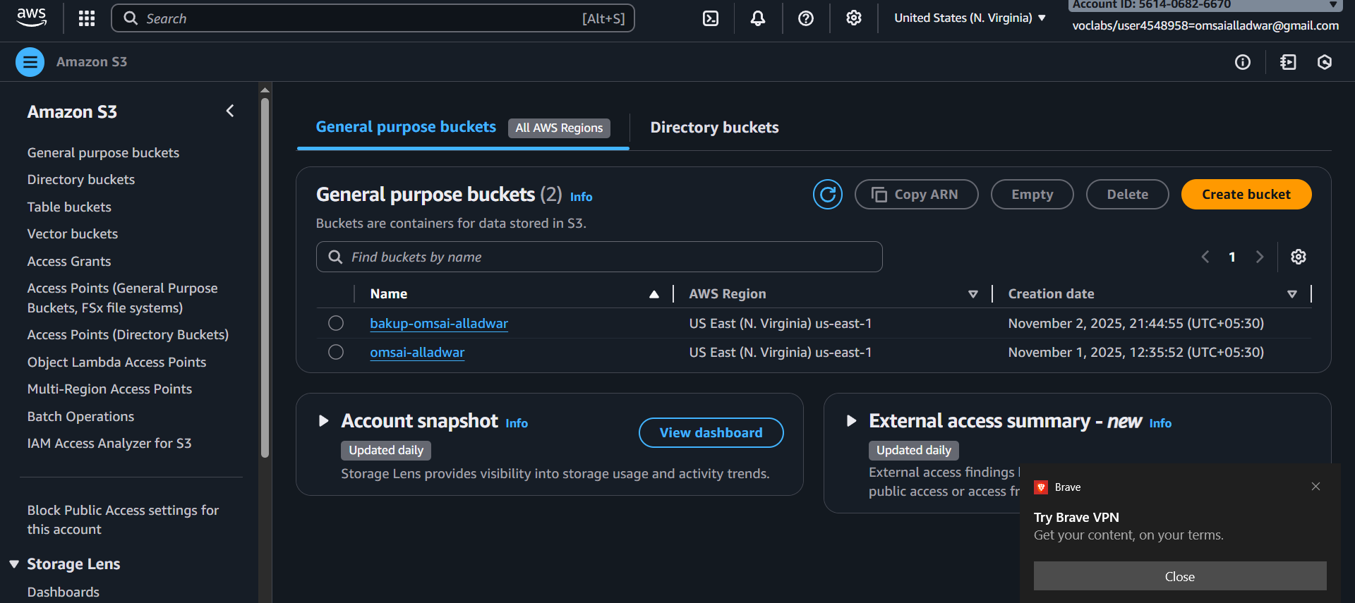

Added a layer in lambda to import pillow library
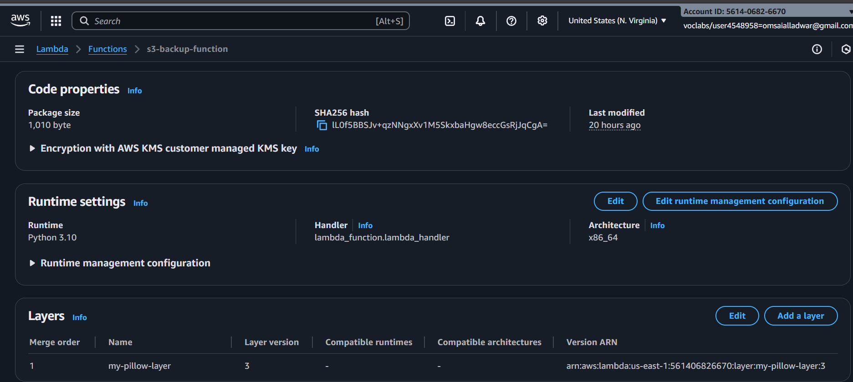

Added code to lambda function to compress the image file and save to backup bucket compressed folder

import urllib.parse
import boto3
from io import BytesIO
from PIL import Image

s3 = boto3.client('s3')

DEST_BUCKET = "bakup-omsai-alladwar"
DEST_PREFIX = "compressed/"
JPEG_QUALITY = 75

def lambda_handler(event, context):
for record in event['Records']:
src_bucket = record['s3']['bucket']['name']
key = urllib.parse.unquote_plus(record['s3']['object']['key'])
print(f"File received: {key}")

# Skip compressed folder to avoid infinite trigger loop
if key.startswith(DEST_PREFIX):
print("Skipping compressed file event")
return

# If JPG/JPEG: compress & upload ONLY compressed version
if key.lower().endswith((".jpg", ".jpeg")):
print("JPG detected → compressing...")
try:
obj = s3.get_object(Bucket=src_bucket, Key=key)
img_data = obj['Body'].read()

img_stream = BytesIO(img_data)
with Image.open(img_stream) as img:
if img.mode not in ("RGB", "L"):
img = img.convert("RGB")

out = BytesIO()
img.save(out, format="JPEG", quality=JPEG_QUALITY, optimize=True)
out.seek(0)

compressed_key = DEST_PREFIX + key

s3.put_object(
Bucket=DEST_BUCKET,
Key=compressed_key,
Body=out,
ContentType="image/jpeg"
)

print(f" Compressed uploaded: {DEST_BUCKET}/{compressed_key}")
return # DO NOT copy original

except Exception as e:
print(f" Compression failed: {e}")

# For non-images OR fallback: copy normally
print("Normal file → copying backup")
s3.copy_object(
Bucket=DEST_BUCKET,
Key=key,
CopySource={'Bucket': src_bucket, 'Key': key}
)
print(f" File copied: {DEST_BUCKET}/{key}")

added an jpg image to first bucket
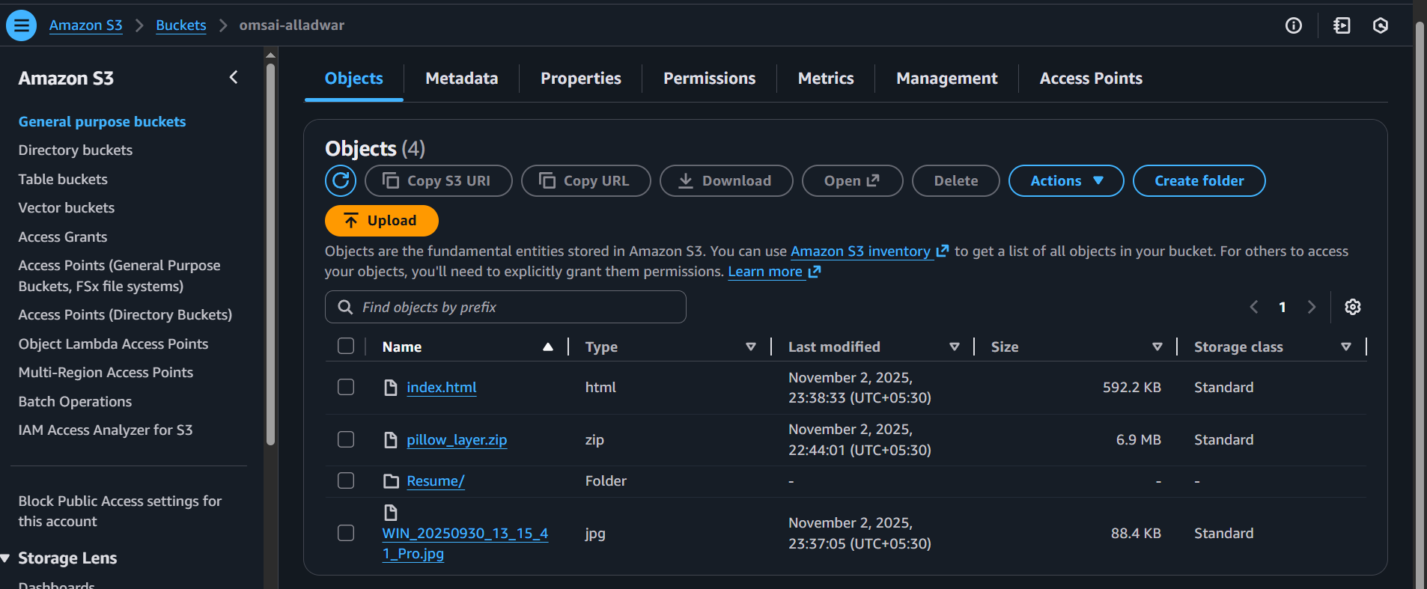

Image got compressed and put into compressed folder into 2nd backup bucket
